Beam Controller - Software Development Specification

Important: This document should be treated as a version controlled document. This document is contained in the "_Repo" drive, and this drive should be considered analogous to the master branch of a version controlled repository. This specification should be updated periodically while scratch work for each sub-system occurs in folders other than "_Repo".

Intended Purpose & Scope 2
Operational Scenarios 2
System, Sub-systems, & Supra-System Descriptions (define sys boundaries) 2
Interface Identification (to other systems) 2
Risks and assumptions 2
General Constraints (Project, Enterprise, External) 2
Design Constraints 2
Test Plan Summary (outline of what needs to be measured) 2
Define Measures of Effectiveness 2
Requirements & Fulfillment Analysis (inc applicable Functional Baseline reqs) 2
Describe Life Cycle Concepts (consumables, maintenance, repair) 2
Design Analyses 2
Notes & Tasks (e.g. notes to consider integrating or future dev) 3
Useful References 3
Functional Block Diagrams 3
Software Concept: 3

***See also corresponding Hardware Dev Spec. Note that the Software Dev Spec is simply an extension of the primary Hardware Dev Spec, so the engineer must read and understand the Hardware Dev spec as well to properly design the software.

Intended Purpose & Scope
See also: BCON HW Dev Spec _2026-03-17A-CMcD
The purpose of BCON software is to provide remote control of electron beam deflection and pulsing operations for metal melting experiments. The software enables:
- Three independent beam control channels (Beam A, B, C) with individual pulsing parameters
- Beam deflection control via solenoid current modulation using a Kepco bipolar operational power supply
- Real-time physics calculations (B-field, power dissipation, beam deflection, scan speed)
- Safety-critical monitoring with watchdog protection and fail-safe behavior
- Energy-aware lookup table (LUT) calibration system for accurate deflection calculations across different beam energies (20-50 keV)
BCON is divided into three distinct functional modules handled by different subsystems:
- BCON Arduino (Pulser Control & Safety): Handles control of the pulsers and corresponding hardware/software safety interlocks.
- Kepco BOP Amp Control (Kepco dashboard): Handles Kepco command generation and sends commands to the Kepco 802E card to generate the waveform for the solenoids.
- Dashboard Control: Handles the overarching GUI, BCON logging, beam position estimation, and user parameter input.

Operational Scenarios
See BCON HW Dev Spec _2026-03-17A-CMcD

System, Sub-systems, & Supra-System Descriptions (define sys boundaries)
See BCON HW Dev Spec _2026-03-17A-CMcD

The BCON software module is built within the existing dashboard as an additional subsystem. Both the user interface and backend drivers are written entirely in Python.

Software Architecture:
Main Dashboard (Tkinter Application)
│
├── BeamPulseSubsystem (subsystem/beam_pulse/beam_pulse.py)
│ │ - GUI: Main Tab + Config Tab
│ │ - LUT Management System (via git submodule: EBEAM_dashboard_LUT)
│ │ - Beam Position Tracking (step-based history)
│ │ - Safety Monitoring Loops
│ │
│ └── E5CNModbus (instrumentctl/E5CN_modbus/E5CN_modbus.py)
│ │ - Modbus RTU Communication
│ │ - Register Read/Write Operations
│ │ - Thread-safe locking
│ │
│ └── RS-485 Hardware Interface
...

Key Software Components:
- BeamPulseSubsystem Class (beam_pulse.py)
  - Dual-mode operation: GUI mode (with parent_frame) or headless mode (without)
  - Manages all beam control logic and user interactions
  - Performs real-time physics calculations
  - Implements safety features and monitoring loops
- BCONModbus Class (BCON_modbus.py)
  - Low-level hardware driver extending E5CNModbus base class
  - Thread-safe Modbus communication with locking mechanism
  - Implements complete register map (19 registers)
- LUT File System
  - CSV files stored in beam_pulse/ directory
  - Energy-specific naming: beam_deflection_20keV.csv, scan_speed_30keV.csv
  - Automatic file discovery and dropdown population
  - Linear interpolation between data points

System Boundaries:
Inputs to BCON Software:
- User commands via Tkinter GUI (button clicks, spinbox values, dropdown selections)
- Beam energy data from BeamEnergySubsystem (power supply voltages)
- Hardware status from BCON microcontroller via Modbus RTU
- LUT calibration data from CSV files
Outputs from BCON Software:
- Modbus register writes to BCON hardware (commands, parameters, waveform settings)
- Visual displays: connection status, beam LEDs, deflection stats, position plots
- Calculated physics parameters: B-field, power, deflection, scan speed
- Log messages for debugging and system monitoring
External Systems:
- BCON Hardware (Pulser Arduino + Kepco BOP Amp + Kepco 802E + PVX-4150 pulsers)
- BeamEnergySubsystem (for current beam energy calculation)
- Main Dashboard Control Panel (for system-wide coordination and arming)
- Knob Box (for physical interlocks, though monitoring not yet implemented)

Interface Identification (to other systems)
See also:BCON HW Dev Spec _2026-03-17A-CMcD

- Communication to Kepco 802E for waveform generation and pulser control uses telnet commands over Ethernet
- Communication to Pulser Arduino for pulser control uses Modbus over RS-485
Modbus Packet definition:

Beam Controller Modbus register information:

Register Number | Register name | Register function
0 | COMMAND | Command register.  See command description.
1 | X_DIRECT_WRITE | Direct write value to DAC, in direct command mode
2 | Y_DIRECT_WRITE | Direct write value to DAC, in direct command mode.  Not using currently.
3 | PULSER_1_DUTY | PWM duty cycle, output to pulser. Uint8_t type, default: 0
4 | PULSER_2_DUTY | PWM duty cycle, Not using
5 | PULSER_3_DUTY | PWM duty cycle, Not using
7 | PULSER_2_DURATION
8 | PULSER_3_DURATION
9 | SAMPLES_RATE | Number of samples per waveform period. Uint16_t type, default: 8192
 | BEAM_1_AMPLITUDE | Amplitude value for waveform generation. Uint16_t type, default: 32767
 | BEAM_1_PHASE | Phase value for waveform generation. Uint16_t type, default: 0
 | BEAM_1_OFFSET | Offset value for waveform generation. Uint16_t type, default: 0
 | BEAM_2_AMPLITUDE | Amplitude value for waveform generation. Uint16_t type, default: 32767
 | BEAM_2_PHASE | Phase value for waveform generation. Uint16_t type, default: 0
 | BEAM_2_OFFSET | Offset value for waveform generation. Uint16_t type, default: 0
 | BEAM_3_AMPLITUDE | Amplitude value for waveform generation. Uint16_t type, default: 32767
 | BEAM_3_PHASE | Phase value for waveform generation. Uint16_t type, default: 0
 | BEAM_3_OFFSET | Offset value for waveform generation. Uint16_t type, default: 0

Command Register (0) Values:

Command | Value | Description
Direct Write X | 0 | Write X_DIRECT_WRITE to DAC (fixed deflection)
Direct Write Y | 1 | Write Y_DIRECT_WRITE to DAC
Sawtooth Wave | 2 | Generate sawtooth waveform
Sine Wave | 3 | Generate sine waveform
Triangle Wave | 4 | Generate triangle waveform
Humming Wave | 5 | Generate humming waveform

Risks and assumptions
See BCON HW Dev Spec _2026-03-17A-CMcD

- Poorly documented / commented code making it difficult for anyone other than the original developer to maintain and build on.
- Miscommunication between python backend drivers and Arduino firmware.
- Dashboard will not provide real-time pulser voltage/current feedback; assume oscilloscope diagnostics are sufficient for early tests.
- LUT Energy Mismatch: Using wrong energy LUT file (e.g., 20keV data at 50keV operation) causes incorrect deflection calculations. Mitigation: Energy validation warnings in Config tab
- (Related to previous issue) - CSV File Format: Incorrect LUT file format causes calculation failures Mitigation: Column validation on load, fallback formulas
- Loss of communication to 802E results in continued output from the Kepco BOP amp
- Loss of communication to pulser Arduino must be accounted for with a watchdog to ensure grids go low
- Pulser Arduino software crashes must be handled by a hardware watchdog to ensure grids go low

General Constraints (Project, Enterprise, External)
See BCON HW Dev Spec _2026-03-17A-CMcD

Design Constraints
See BCON HW Dev Spec _2026-03-17A-CMcD

Test Plan Summary (outline of what needs to be measured)
See BCON HW Dev Spec _2026-03-17A-CMcD

Define Measures of Effectiveness
See BCON HW Dev Spec _2026-03-17A-CMcD

Requirements & Fulfillment Analysis (inc applicable Functional Baseline reqs)
See also:BCON HW Dev Spec _2026-03-17A-CMcD
Functional Requirements:
- FR-SW-001: Dashboard shall display BCON connection status
- FR-SW-002: System shall support three independent beam controls (A, B, C)
- FR-SW-003: User shall be able to select waveform type: Sine, Triangle, Pulse, Fixed
- FR-SW-004: Frequency control shall be disabled when Fixed waveform is selected
- FR-SW-005: System shall calculate and display: Max Deflection (cm), Scan Speed (m/s), B-field (G), Power (W)
- FR-SW-006: Config tab shall allow setting deflection amplitude bounds (±A) and frequency bounds (Hz)
- FR-SW-007: System shall load energy-specific LUT files for beam deflection and scan speed calculations
- FR-SW-008: Dashboard shall display beam position history with completed moves (blue) and current position (red)
- FR-SW-009: Pulse duration shall be configurable per beam (1-1000ms)
- FR-SW-010: Beam arming shall be required before any beam can be enabled
Safety Requirements:
- SR-SW-001: BCON shall return deflection to zero if dashboard heartbeat is lost
- SR-SW-002: System shall validate LUT energy matches current beam energy
- SR-SW-003: Deflection amplitude shall be constrained by user-configured bounds
- SR-SW-004: Safe shutdown shall zero all pulser duties and durations
Performance Requirements:
- PR-SW-001: GUI update rate shall be ≥2Hz (500ms loop)
- PR-SW-002: BCON connection monitoring shall poll every 5 seconds
- PR-SW-003: LUT interpolation shall use linear interpolation between data points
- PR-SW-004: Deflection stats shall update every 500ms

Describe Life Cycle Concepts (consumables, maintenance, repair)

Design Analyses
Calculations:
- B-field Calculation: Linear approximation using empirical constants
  - Center beam (B): 38.875 G/A
  - Off-axis beams (A, C): 38.25 G/A
  - Source: "2019-09-26 field measurements - 2 solenoids no covers.xlsx"
- Power Calculation: Empirical formula P = 14.810 * I + 0.793 (Watts)
  - Source: "Copy of SA-ATEST-100 110 Plots" (R² = 0.9874, 44 data points)
- Beam Deflection: LUT-based interpolation from CSV files
  - Format: current_amplitude_A → deflection_cm
  - Energy-specific calibration required (20keV, 30keV, 50keV)
- Scan Speed: LUT-based interpolation from CSV files
  - Format: frequency_hz → scan_speed_mps
  - Energy-specific calibration required
Energy-Aware LUT System:
- Why needed: Deflection sensitivity changes with beam energy (20keV vs 50keV)
- Implementation: Separate CSV files per energy level
- Validation: Automatic energy mismatch warnings in Config tab
- Integration: Reads total beam energy from power supply voltages

Notes & Tasks (e.g. notes to consider integrating or future dev)
- [Removing] Pulser voltage/current dashboard plots.

- [Removing] Extraction Pulse monitoring.

- [Removing] Wave Gen Signal monitoring.

- [Pending Decision] Kepco output monitoring implementation method (Telnet driver vs. oscilloscope with current transformer).

- [Future Work] Possible reintegration of pulser diagnostics if needed for future experiments.

Useful References

Functional Block Diagrams

Software Concept:
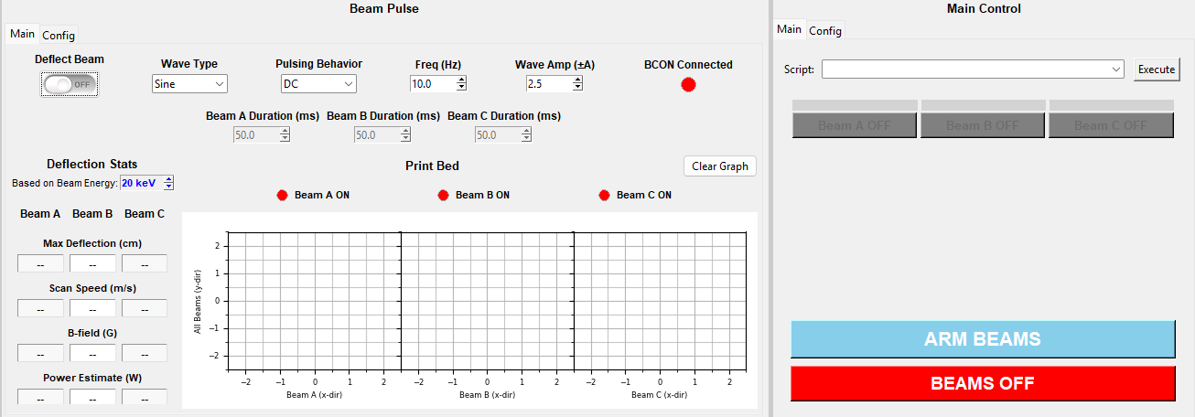
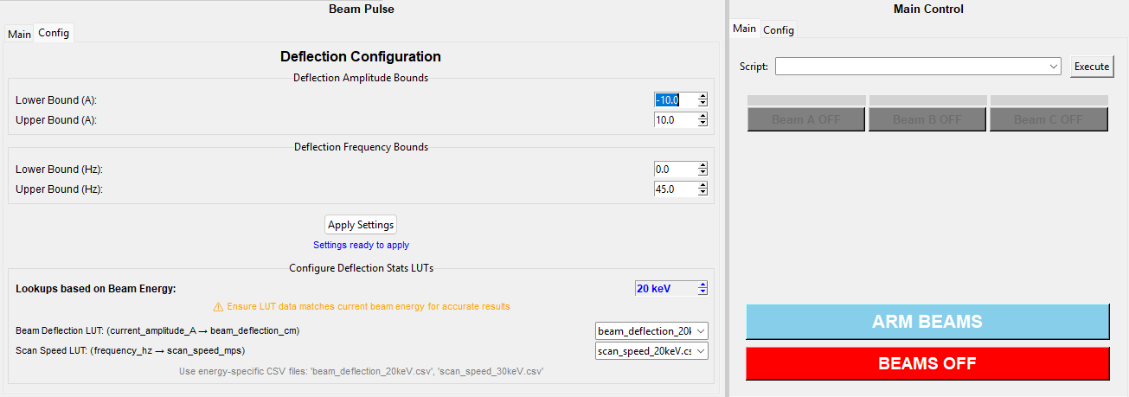
(Source: Screenshot from dashboard running on feature/BCON branch, December 9, 2025).

How to use Modbus to configure&control Beam controller:

